***Fundraising management web application***

Criteria

1. Write requirements from the client description with appropriate user roles and their functionality

2. Add additional requirements from yourself would be remarkable

3. Create UML activity diagram

4. Create prototype

5. Prepare a presentation

1.Write requirements from the client description with appropriate user roles and their functionality

Based on the client description of the Fundraising Management Web Application, we can identify several requirements and associated user roles. Here are the requirements with their respective user roles and functionalities:

1. Donor :

- User Role: Donor

- Functionality: view website ,view volunteer ,contact us , view event , project , event map , also log in or sign up .

2. Donor Relationship Management:

- User Role: Administrator/Donor Relationship Manager

- Functionality: Maintain a centralized database of donors and prospects, track donor interactions, communication history, contributions, and engagement activities.

3. Campaign Planning and Execution:

- User Role: Campaign Manager

- Functionality: Plan and organize fundraising campaigns, set campaign goals, define target audiences, create fundraising events, design marketing materials, and integrate online donation platforms for secure donation collection.

4. Donation Tracking and Reporting:

- User Role: Financial Manager

- Functionality: Efficiently track and manage donations received, record donor details, contribution amounts, and payment methods, generate reports and analytics to gain insights into fundraising performance, donor retention rates, and campaign success metrics.

5. Communication and Engagement:

- User Role: Communication Manager

- Functionality: Facilitate effective communication with donors through email campaigns, newsletters, and personalized messages, segment donor lists, schedule automated communications, and track engagement metrics.

6. Volunteer Management:

- User Role: Volunteer Coordinator

- Functionality: Recruit, manage, and communicate with volunteers, assign tasks, track volunteer hours, provide necessary training materials, and ensure smooth coordination and engagement.

7. Data Security and Privacy:

- User Role: System Administrator

- Functionality: Ensure data security and privacy, implement data encryption, access controls, regular backups, and compliance with data protection regulations such as GDPR.

8. Integration and Customization:

- User Role: System Administrator/IT Manager

- Functionality: Integrate with CRM systems and fundraising platforms for data synchronization, customize the web application to match the branding and specific needs of each nonprofit organization.

These requirements and user roles provide an overview of the key functionalities and responsibilities within the Fundraising Management Web Application. Depending on the specific needs of the organization, additional roles and functionalities may be identified and incorporated into the system.

2. Add additional requirements from yourself would be remarkable

Certainly! Here are some additional requirements that would enhance the Fundraising Management Web Application:

1. Event Management:

- User Role: Event Coordinator

- Functionality: Plan, manage, and promote fundraising events within the application, including event registration, ticketing, attendee management, venue coordination, and event analytics.

2. Social Media Integration:

- User Role: Social Media Manager

- Functionality: Integrate with popular social media platforms to facilitate seamless sharing of fundraising campaigns, events, and success stories, increasing reach and engagement with potential donors.

3. Automated Reminders:

- User Role: Administrator

- Functionality: Set up automated reminders and notifications for upcoming campaigns, events, and donation deadlines to both donors and internal stakeholders, ensuring timely action and participation.

4. Matching Gift Tracking:

- User Role: Donor Relationship Manager

- Functionality: Track and manage corporate matching gift programs, allowing donors to easily submit matching gift requests and monitor their status within the web application.

5. Peer-to-Peer Fundraising:

- User Role: Peer-to-Peer Fundraising Coordinator

- Functionality: Enable individuals to create personal fundraising pages linked to the organization's campaigns, empowering them to fundraise on behalf of the nonprofit and expand the reach of the campaigns.

6. Impact Reporting:

- User Role: Impact Analyst

- Functionality: Generate comprehensive reports on the impact of donations and fundraising efforts, showcasing how donor contributions have made a difference to the organization's mission and projects.

7. Donor Recognition:

- User Role: Donor Relationship Manager

- Functionality: Implement a donor recognition program within the application, acknowledging and appreciating donors for their contributions, milestones, and ongoing support.

8. Mobile Application:

- User Role: Mobile App User

- Functionality: Develop a mobile application companion to the web application, providing on-the-go access to fundraising campaigns, donation options, event updates, and communication features.

9. Gamification Elements:

- User Role: Campaign Manager

- Functionality: Incorporate gamification elements into fundraising campaigns to increase donor engagement, such as leaderboards, badges, and challenges, fostering a sense of competition and motivation among participants.

These additional requirements aim to enhance user engagement, expand fundraising opportunities, and provide a more comprehensive and personalized experience for both donors and internal stakeholders.

3. Create UML activity diagram

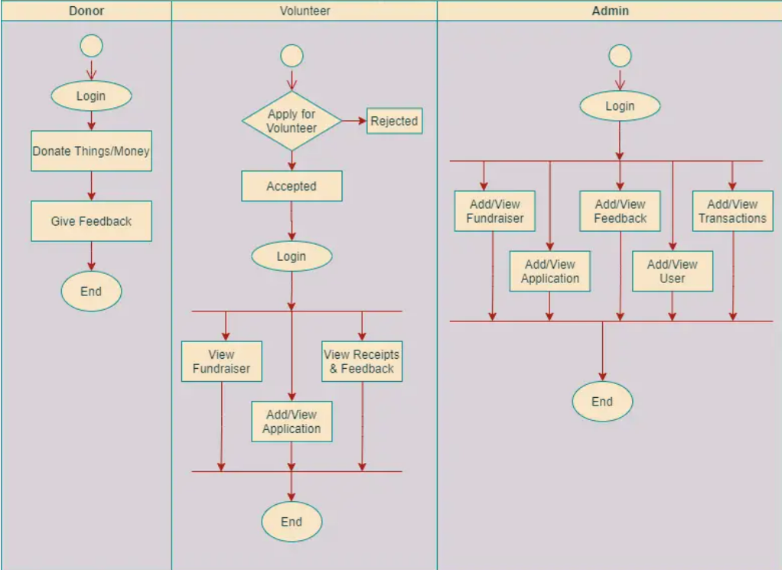

4. Create prototype

Prototype Link : https://www.figma.com/file/rxjvv6jiSLYufG4RNoKaks/Fund_bd?type=design&node-id=0-1&t=IbmuirDuOuDuKTEm-0